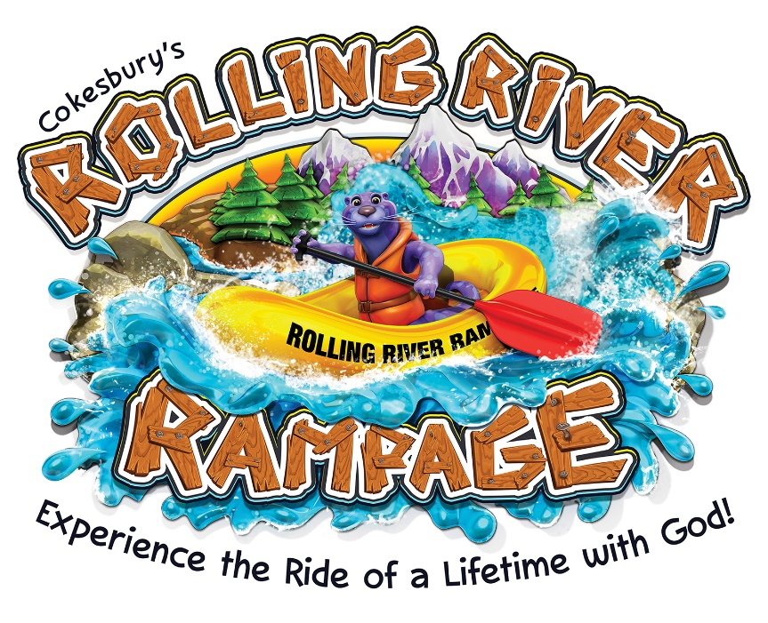
What: Vacation Bible School, age 4 to grade 6
When: July 9-13, 9:00 AM – Noon
Where: Puyallup United Methodist Church
1919 West Pioneer, Puyallup WA 98371
Cost: Free!
How to sign up: www.puyallupumc.org
Child Safety: All leaders cleared through background checks and safety training.
Activities: Opening assembly with high-energy singing, then Bible Story Station, Arts and Crafts Station, Music Station, Science Station, Recreation Station, and Snack Station. (Note: The Rolling River Rampage takes place on dry land. No water worries!)
For More Info: Call the church office at 253-845-0547

